Azure Storage Operations by Using Windows PowerShell ISE

This tutorial demonstrates the following operations by Windows PowerShell ISE

* Creating an Azure Blob Storage account (non-classic version)
* Creating a container in that storage account
* Seeing what containers exist within the storage account.
* Uploading data to that container
* Seeing items are inside of that container
* Deleting an item in that container
* Deleting the container
* Deleting the storage account

Prerequisites:

* Azure subscription or free trial account ([30 day free trial](https://azure.microsoft.com/en-us/pricing/free-trial/))
* Azure PowerShell ([link](https://github.com/Azure/azure-powershell/releases/download/v3.6.0-February2017/azure-powershell.3.6.0.msi))
* Windows PowerShell ISE ([link](https://www.microsoft.com/en-us/search/DownloadResults.aspx?q=%22windows%20management%20framework%22%20PowerShell&sortby=Relevancy~Descending))

Subscribe of free trial account to Azure Storage:

1. Follow the link provides in ‘Prerequisite’ and click on ‘Start Free’
2. Follow the instruction after the navigated page and complete subscriptions

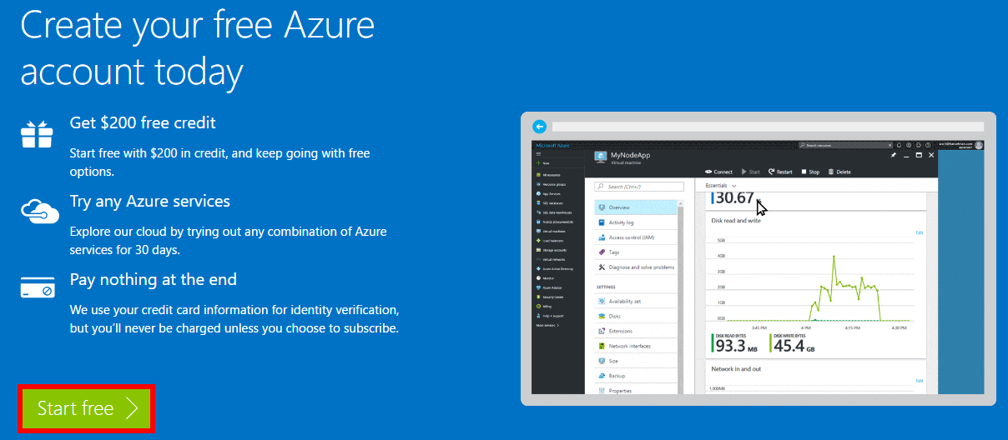

Setting up Azure PowerShell and Windows PowerShell ISE

1. Follow the Azure PowerShell link provides in ‘Prerequisite’ and install
2. Follow the Windows PowerShell ISE link provides in ‘Prerequisite’ and check for installation or upgrade

#1 Create Creating an Azure Blob Storage account (non-classic version)

1. Open Windows PowerShell ISE
2. Open a new file 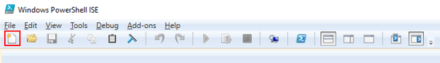
3. Type in instructions to create account (Provided below)

Note: New-AzureStorageAccount takes parameters like

1. Account name (all lower-case and non-existing)

2. Location of storage account

3. Type of storage account

4. Label (optional)

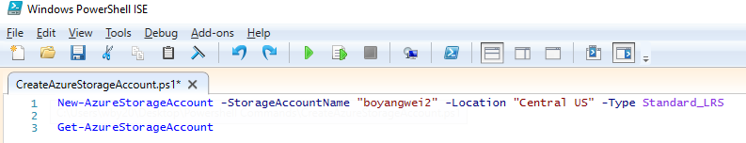

1. Print out the status of Azure Storage Account by using Get-AzureStoageAccount
2. See the output below: (Which can also be seen in Azure Portal visually)

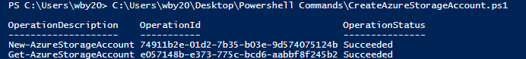

#2 Creating a container in that storage account

1. Open Windows PowerShell ISE
2. Open a new file
3. Type in instructions to create account (Provided below)

1. Account name

2. Storage Key (Found in **All Resources > OverView > Acess Key** )

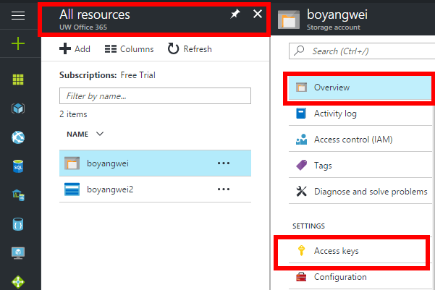

3. Type in the container’s name you want to create

4. Use New-AzureStorageContext and New-AzureStorageContainer

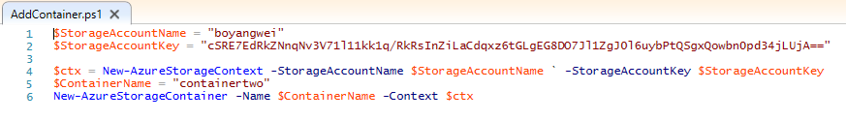

1. Output shown as:

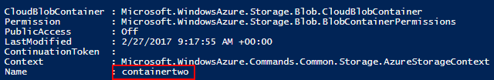

#3 Seeing what containers exist within the storage account.

1. Open Windows PowerShell ISE
2. Open a new file and type in instructions
3. Currently I have 2 containers shown below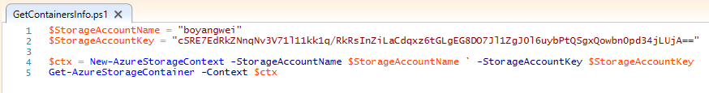

1. Account name

2. Storage Key (Found in **All Resources > OverView > Acess Key** )

3. Use New-AzureStorageContext and Get-AzureStorageContainer

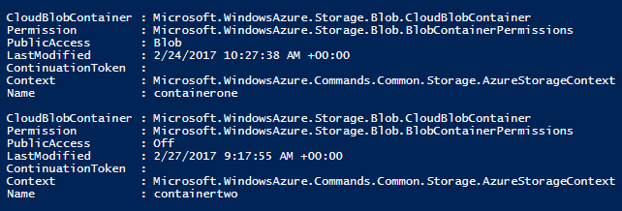

#4 Uploading data to that container

1. Open Windows PowerShell ISE
2. Open a new file and type in instructions
3. I uploaded a txt file as shown below

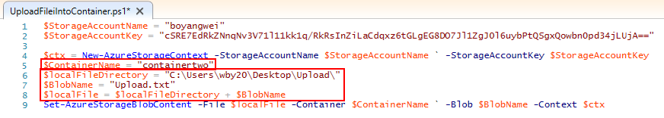

1. Account name and Storage Key

2. Specify the address of local data you want to up load

3. Use New-AzureStorageContext and Set-AzureStorageBlobContent

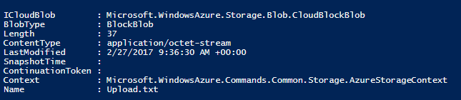

#5 Seeing items are inside of that container

1. Open Windows PowerShell ISE
2. Open a new file and type in instructions

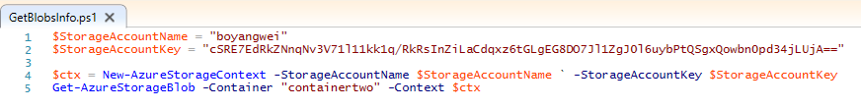

1. Account name and Storage Key

2. Name of container you want to peek into

3. Use New-AzureStorageContext and Get-AzureStorageBlob

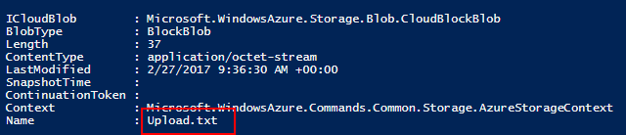

# 6 Deleting an item in that container

1. Open Windows PowerShell ISE
2. Open a new file and type in instructions

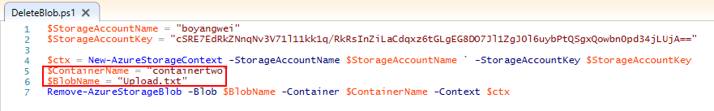

1. Account name and Storage Key

2. Name of the container and data you want to delete

3. Use New-AzureStorageContext and Remove-AzureStorageBlob



# 7 Deleting the container

1. Open Windows PowerShell ISE
2. Open a new file and type in instructions

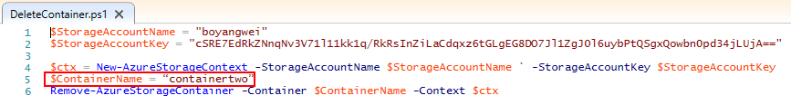

1. Account name and Storage Key

2. Name of the container you want to delete

3. Use New-AzureStorageContext and Remove-AzureStorageContainer



# 8 Deleting the Storage Account

1. Open Windows PowerShell ISE
2. Open a new file and type in instructions including the name of storage account you want to delete
3. Results shown below:



